Algebra 1: Unit 6, Lesson 5

- An inequality is shown.
$$y-2<\frac{3}{5}(2x+6)$$
Determine if the point $\left(-1, \frac{1}{2}\right)$ is a solution to the inequality.
is

- The graph of the line $y=-2x+3$ and some points are shown.
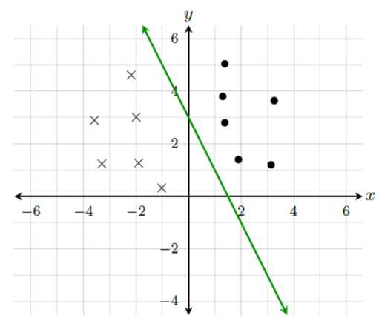
What is the inequality with a solution set that includes the dots?
$$y>-2x+3$$

- The graph of the inequality $y>2x-2$ is shown.
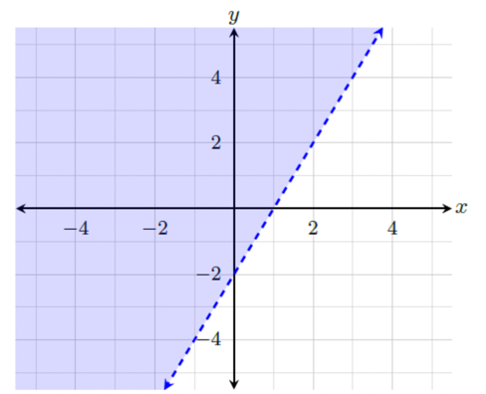
The coordinate $(0,-2)$ __________ a solution to the inequality.
is not

